# THE SCANNER:

### by: 102156 - Papa Blaise

The scanning phase is the first phase in the front end of a compiler. Using the character stream as input, finds a substring of the characters that constitute the textual elements. The scanner identifies the substrings and classifies them their respectful textual elements i.e words,punctuation,white-spaces, comments.

The scanner outputs a token stream which has uniquely identified the characters and terminal symbols in the source code,it is free from white spacing.

The code given below:

1. int main()
2. {
3. float radius, area;
5. cout << "Enter the radius of circle : ";
6. cin >> radius;
7. area = 3.14 * radius * radius;
8. cout << "Area of circle with radius "
9. }

when passed through a lexical analyzer as done in Lab 1 will have the following output:

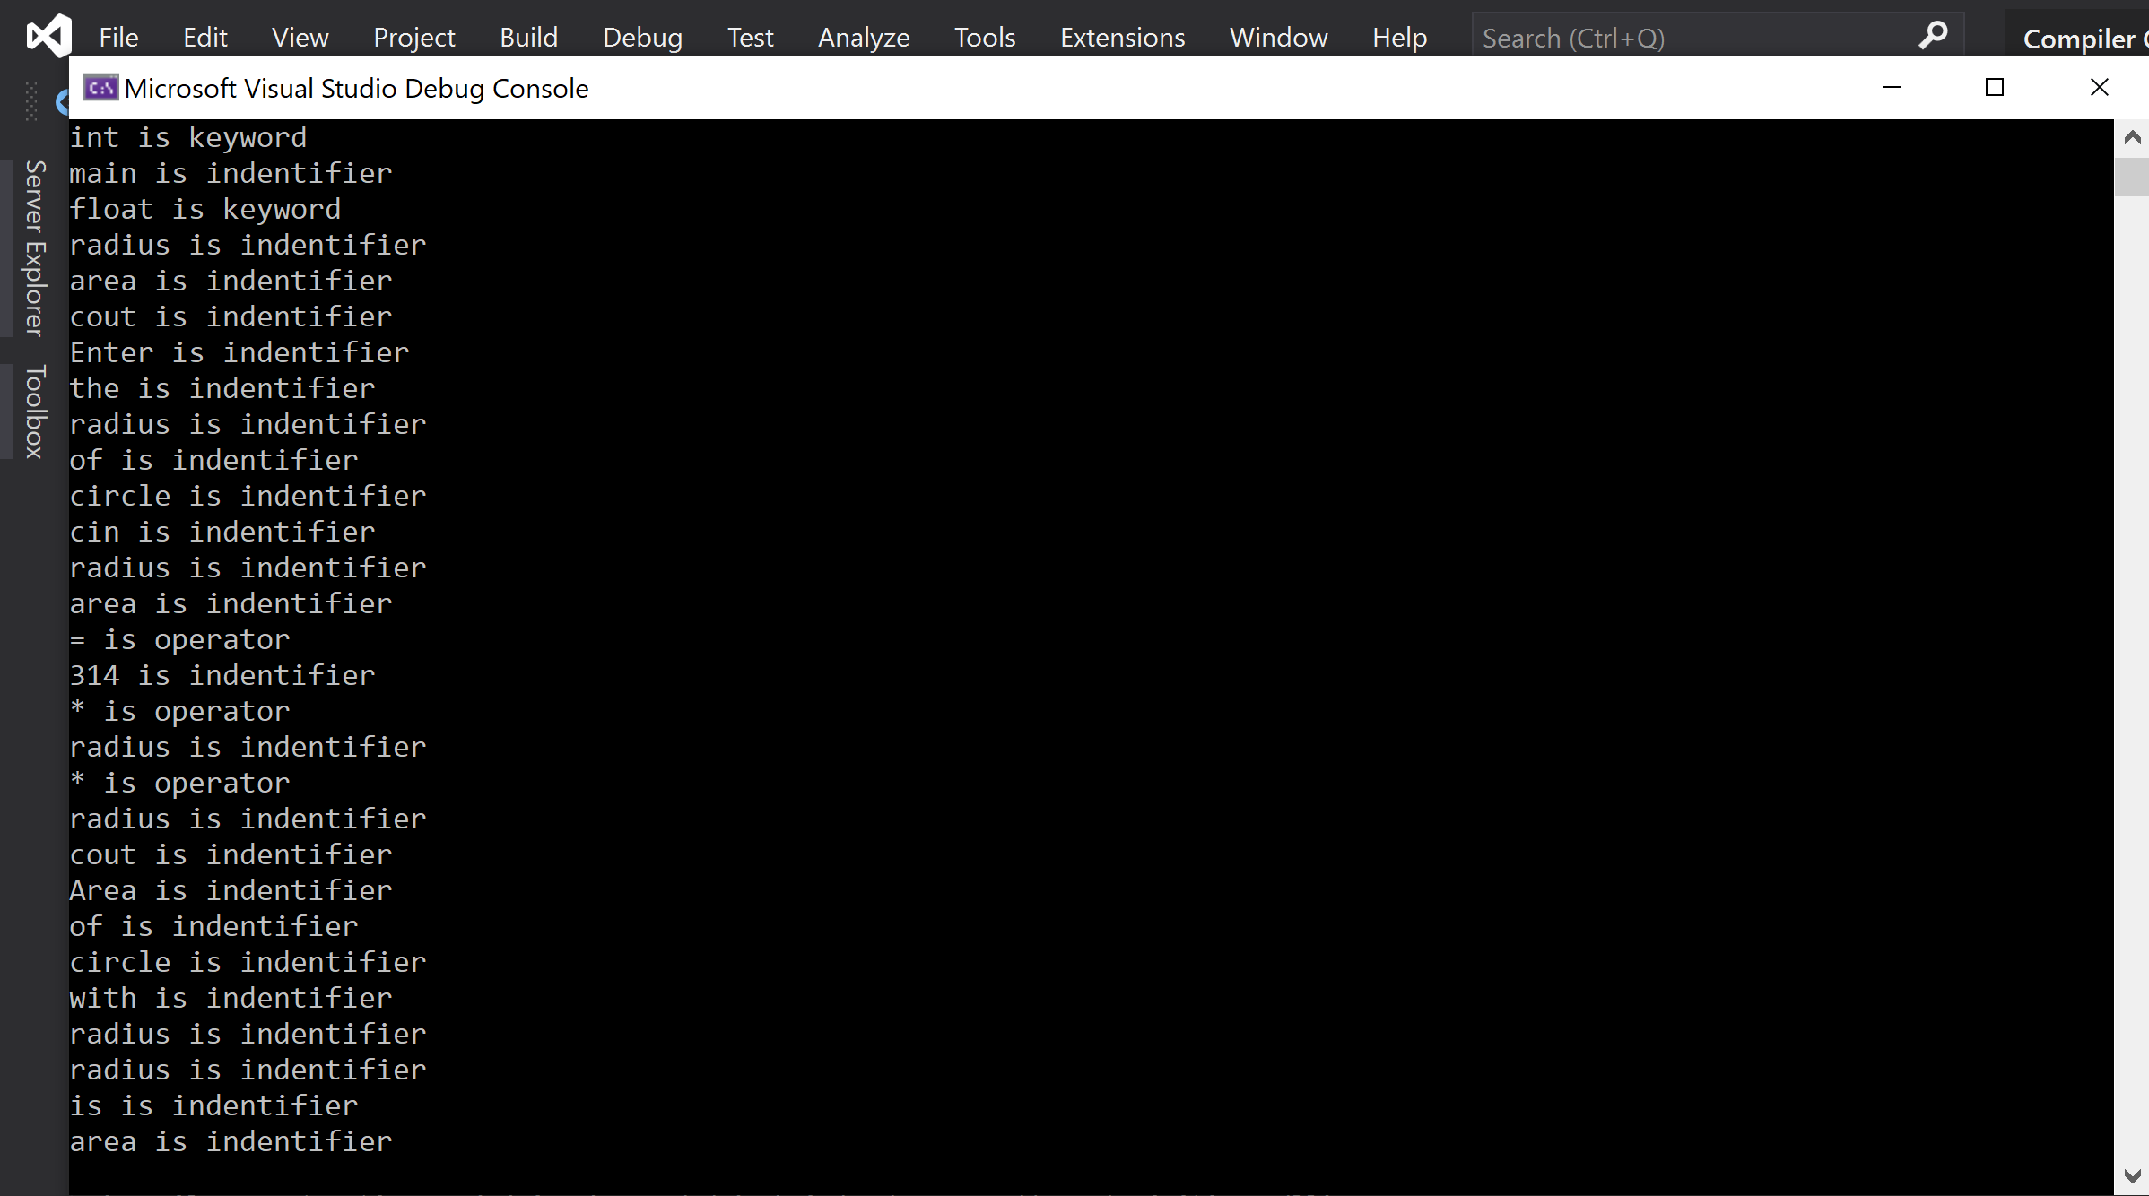

The output from the scanner would look something like the picture above.

Having looked at the source code it does a step by step analysis of characters to determine the substring and textual elements it constitutes.

1. int main() ← identifies a key words in (int and main) which signal the start of the program
2. ←This is whitespace used to make code easier to read this isn't necessary to the compiler hence the scanner does away with it anywhere in the program
3. { ← identifies a symbol
4. float radius, area; ← all the white spaces in this statement are done away with

↑ ↑ ↑

keyword identifier identifier.

↓

1. cout << "Enter the radius of circle : ";

1. cin >> radius;
2. area = 3.14 * radius * radius;
3. cout << "Area of circle with radius "
4. }